傳送日期﹕ 2010/4/30 (五) 6:27:29 PM
主題： March 6, 2010 gathering at Mok Lai Ying's New Townhouse in Richmond BC

Hi, thanks to Frankie Wong, Barbara Chan Mei Har's husband, some of us who were at the party were given a DVD recorded by him of some good parts of the evening, eg our dinner, our game, our karoake singing. It is almost 45 mins long and I am not sure if I want to put such a long video on the web. My daughter helped me to capture some pics so that I can email them to you and those who are far away from us. The pics are not so clear but at least you know we had a good time. The wooden bucket is the "soya flower" made by Mok Lai right after dinner, so it is hot and delicious. Must say Mok Lai is a wonderful host and knows what she is doing. The Roast Pork I tried to make was not bad but the skin is not crispy enough. It has to do with that small oven that I used and not enough holes being punched on the skin. I will try again at the next opportunity. Watt Sir, still the centre of our celebration, was having a lot of fun, singing and laughing. Ms Leung was unable to join as she was exhausted from the long trip and after the earthquake she experienced somewhere in Chile. Cannot remember the name of the city. She was not hurt but shocked and thankful to God that everything was allright.

To those who may not remember all of us, if you are looking at the pic below:
Front row: L to R - Susanna Lee Yuk Lin; Edith Yeung Lai Ngor; May Yeung Yee Ling; Marianna Poon Wai Ching; Watt Sir, Brenda Chu Kit Ching; Winnie Ho Shuk Ming; Rosa Yu Mei Hung
Standing: L to R - Linda Louie King Sin; Ng Chiu Choi; Bill Tse May's husband; Poon Mo Chor; Stephen Cheung Linda's husband; Angela Poon Mo Chor's wife; Barbara Chan Mei Har; Theresa Mok Lai Ying.

Good nite
Susanna

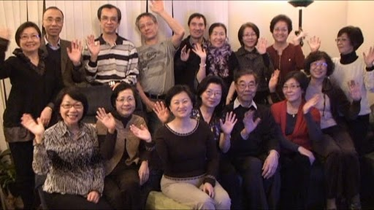 http://picasaweb.google.com/lh/sredir?uname=joycecsng&target=ALBUM&id=5465764013702661761&authkey=Gv1sRgCMvV1Z60nMv0uAE&invite=CKXAmvwF&feat=email (Photos from DVD posted by Joyce Ng)

